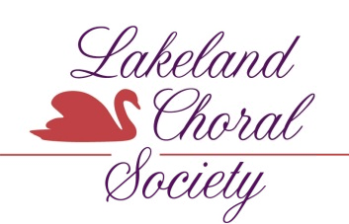

LAKELAND CHORAL SOCIETY
VOCAL SCHOLARSHIP
High School Application
ELIGIBILITY:
In order to participate in the Lakeland Choral Society’s Vocal Scholarship Competition, students must:
- Submit a completed application form.
- Be a graduating high school senior (who attends Polk County high schools or studies with Polk County teachers) who plans to major in vocal performance, music education, or choral conducting at any college or university.
- Maintain a minimum 3.0 GPA.
- Submit official school transcripts.
- Include a personal letter providing relevant information about herself/himself, including career goals.
- Submit a letter of recommendation from a music teacher.
- Complete live auditions if selected as finalists.
*Please check off each of the above items as you complete your application package. Incomplete applications will be automatically disqualified.

APPLICANT INFORMATION
Applicant’s Name:___________________________________________________________________________________
Date of Birth:_____________________ Phone (Cell):__________________Phone(Home):_________________________
Applicant’s Email:____________________________________________________________________________________
Permanent Address: _________________________________________________________________________________
City:__________________________ State:______________________________ Zip Code:________________________
Mailing Address (if different from above):________________________________________________________________
City:__________________________ State:_______________________________ Zip Code:________________________
Name of Parent(s)/Guardian(s):________________________________________________________________________
Parent’s/Guardian’s Address:__________________________________________________________________________
City:__________________________ State:_______________________________ Zip Code:________________________

School currently attending:____________________________________________________________________________
College/university attending in fall:______________________________________________________________________
Location:______________________________________________________________________Accepted? Yes___ No___

Please list any recent musical awards, honors or achievements that you have earned. Explain.

Please list competitions, recitals, or theatrical productions in which you have participated.

Please list organizations, clubs, or groups in your school, church or community in which you have participated or volunteered.

What are your future plans for musical study and/or your musical career?

What inspired you to choose music as a career?

High School students: All applications and required attachments must be received in your Guidance Office.
High School and Music Counselors, please forward applications to:

Lakeland Choral Society
Hurlburt Financial
5125 South Lakeland Drive, Lakeland, FL 33813

